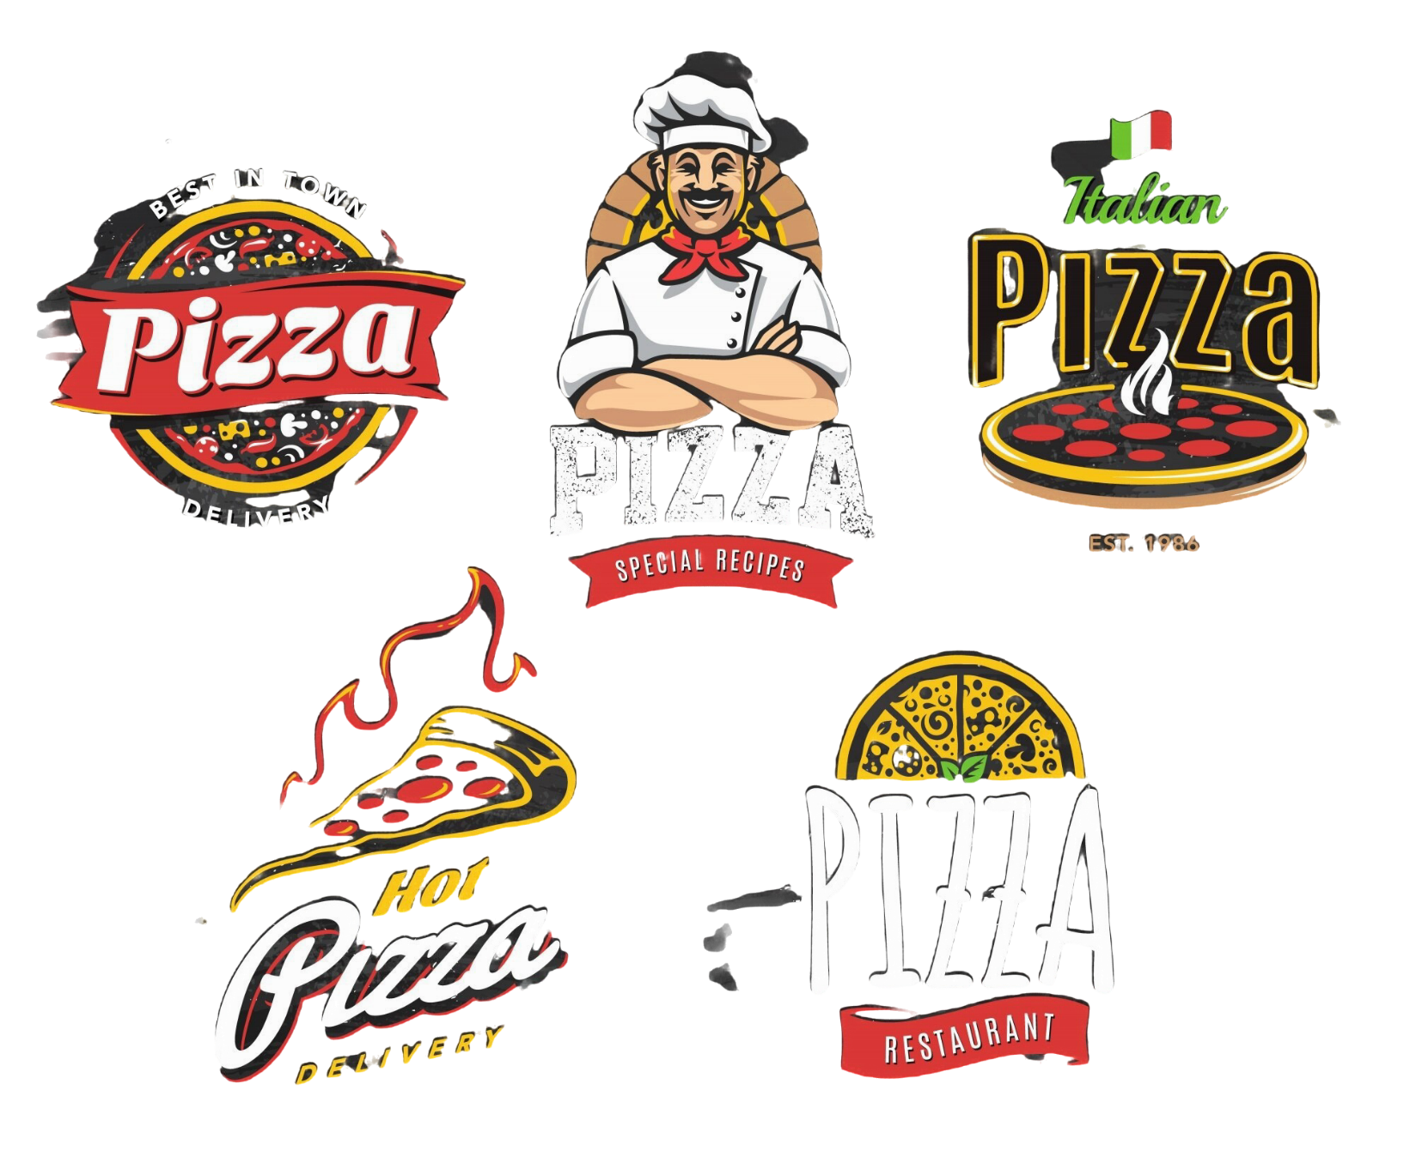

**Sales Analysis and Performance Dashboard for Pizza Place**

**By. Vinayak Naik**

**Project Introduction:**

**The Pizza Place sales analysis project uses Excel to analyze and visualize key business metrics, providing actionable insights into sales performance and customer behavior. The project focuses on total revenue, order trends, sales distribution by pizza categories and sizes, and the performance of best and worst-selling pizzas. By identifying peak sales periods, customer preferences, and underperforming items, the analysis helps optimize marketing strategies, inventory management, and overall operations. This dashboard serves as a valuable tool for data-driven decision-making and continuous performance improvement.**

**Problem Statement of business:**

Pizza Place aims to improve its operational efficiency and sales performance by analyzing key metrics from its sales and customer behavior data. The following business questions guide this analysis:

1. What is the total revenue generated during the period under consideration, and what is the average value of each customer order?
2. How many pizzas have been sold overall, and what is the total number of orders placed?
3. What is the average number of pizzas ordered per transaction?
4. What trends can be identified in daily and hourly sales, and how do these trends correlate with peak business days and times?
5. What percentage of sales can be attributed to each pizza category (e.g., Classic, Chicken, Veggie, Supreme), and how does the distribution vary across pizza sizes?
6. Which pizza category contributes the most to overall sales, and what is the total number of pizzas sold for each category?
7. What are the top 5 best-selling pizzas, and what factors might explain their popularity?
8. Which pizzas are performing the worst in sales, and how can their performance be improved or optimized?
9. How can insights from the above metrics be leveraged to adjust marketing strategies, optimize inventory management, and improve overall customer satisfaction and profitability?

This analysis will serve as a foundation for strategic decision-making, helping Pizza Place enhance its market positioning and operational efficiency.

KPI's REQUIREMENT

1. Total Revenue
2. Average Order Value
3. Total Orders
4. Total Pizzas Sold
5. Average Pizzas Per Order
6. Daily Trend for Total Orders
7. Hourly Trend for Total Orders
8. Percentage of Sales by Pizza Category
9. Percentage of Sales by Pizza Size
10. Total Pizzas Sold by Pizza Category
11. Top 5 Best Sellers by Total Pizzas Sold
12. Bottom 5 Worst Sellers by Total Pizzas Sold
13. Total Revenue





1. Average Order Value





1. Total Orders





1. Total Pizzas Sold





1. Average Pizzas Per Order





1. Daily Trend for Total Orders



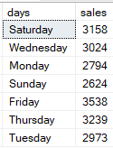

1. Hourly Trend for Total Orders



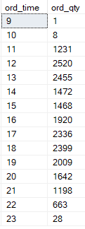

1. Percentage of Sales by Pizza Category



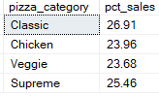

1. Percentage of Sales by Pizza Size



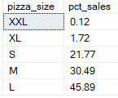

1. Total Pizzas Sold by Pizza Category



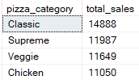

1. Top 5 Best Sellers by Total Pizzas Sold



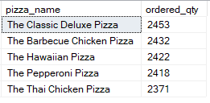

1. Bottom 5 Worst Sellers by Total Pizzas Sold



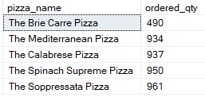

**Software used**

Microsoft SQL-for data query

Microsoft Excel-for dashboarding

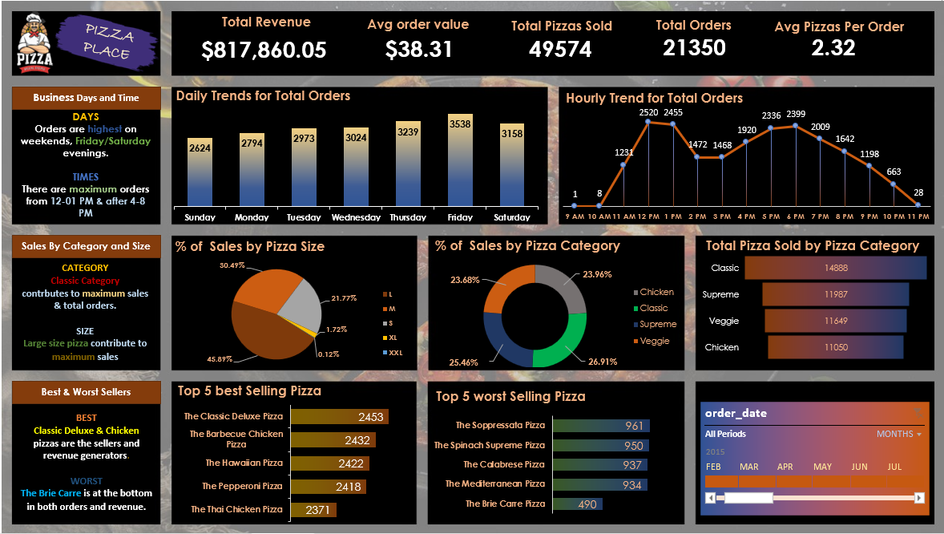

**Project Conclusion:**

The Pizza Place sales analysis project, completed using Excel, successfully provided a comprehensive overview of the business's performance metrics and customer behavior patterns. The dashboard enabled detailed insights into critical sales and operational data, facilitating data-driven decision-making. Key findings from the project include:

1. **Revenue Insights:** Pizza Place generated a total revenue of $817,860.05, with an average order value of $38.31. The business demonstrated strong sales performance, with a total of 49,574 pizzas sold across 21,350 orders, averaging 2.32 pizzas per order.
2. **Order Trends:** Analysis of daily and hourly sales trends highlighted Friday and Saturday evenings as peak periods, with maximum orders occurring between 12 PM–1 PM and 4 PM–8 PM. These insights can inform staffing and inventory planning during high-demand periods.
3. **Category and Size Performance:** The "Classic" category emerged as the top contributor to total sales, with large-size pizzas driving the highest revenue. Classic and Supreme pizzas accounted for 51.92% of sales collectively, emphasizing their popularity among customers.
4. **Best and Worst Sellers:** The top 5 best-selling pizzas, including "The Classic Deluxe Pizza" and "The Barbecue Chicken Pizza," were identified as significant revenue drivers. Conversely, underperforming pizzas like "The Brie Carre Pizza" and "The Spinach Supreme Pizza" present opportunities for repositioning or menu optimization.
5. **Customer Preferences:** The breakdown of sales by pizza size and category provided a clearer understanding of customer preferences, allowing for targeted marketing and promotions to boost sales in specific segments.

The dashboard serves as a user-friendly and dynamic tool for ongoing monitoring of Pizza Place’s performance. By leveraging these insights, the business can optimize inventory management, adjust marketing strategies and enhance customer satisfaction, ultimately driving profitability and growth. This project demonstrates the power of Excel as a versatile tool for data visualization and business analysis, providing actionable insights to support strategic decision-making.

--- END---